**Shuffleboard Curling**

Players can match up head to head (2 players) or in teams of 2 (4 players), with team players alternating play between ends (a player from each team plays from the opposite end of their team mate).

A coin toss determines which team has the hammer for the first end. The hammer is retained until a team scores, and then is awarded in the ensuing end to the team scored against. The hammer is the last stone of the end, which is an advantage.

All rocks must be thrown from the center position of the playing surface (the hack). the shot must originate from the hack And released by the Hog.

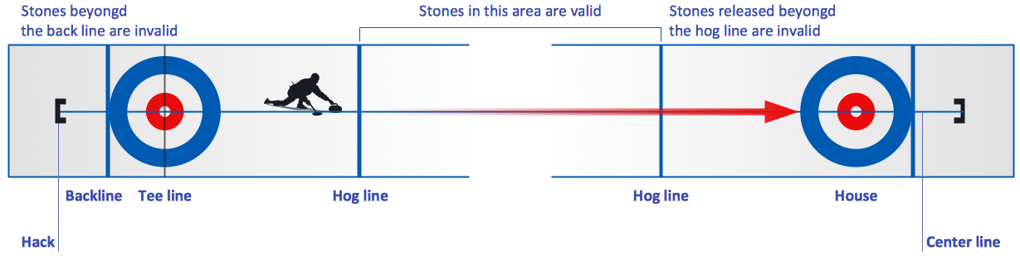

The team’s alternate throws towards the circular target. The object is to have more stones closer to the center than your opponent after all 8 stones have been thrown.

A typical game is played in 8 ends. In each end, 8 stones are thrown. Only 1 team can score in an end;

**Scoring**

The team with the closest stone to the center scores one point for each stone closer than their opponent’s best stone. If players are unable to determine which team’s rock is closest to the button, the end is blanked. The hammer is retained, and teams play to the next end.

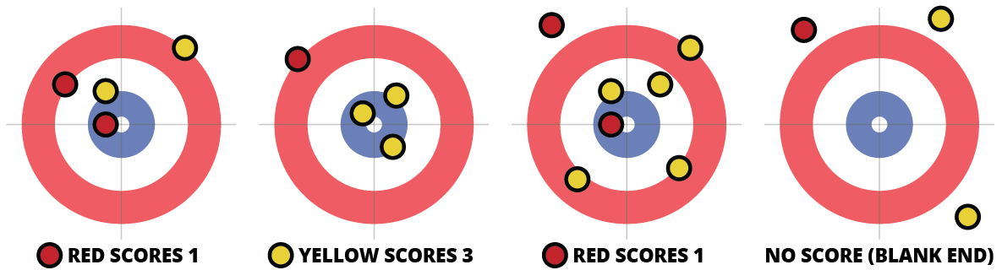

**Deck Shuffleboard**

Players slide pucks alternately starting with red. The sliding motion must start within the 10- off area and finish within the scoring triangle. If a puck does not reach the furthest dead line, it is immediately removed from play. Any puck that tips off the edge of the court is also immediately removed from play. Naturally, players will aim both to push their own puck into the scoring areas or strategically advantageous positions while also attempting to knock opponent’s puck out of play or into the 10 off area.

**Scoring**

Scoring occurs once all eight disks have been played and is according to the areas marked on the court with 10 points being deducted for any disks in the 10-off area. A disk must be entirely within one of the five areas and not touching the outside lines of that area in order to score the amount marked within.

The game is won by the first person to reach 75 points although this cannot be achieved during a game - all eight disks of the final game must be played and the scores calculated before a player can claim victory.

**American Shuffleboard**

The objective of the game is to slide, by hand, all four of one’s weights alternately against those of an opponent, so that they reach the highest scoring area without falling off the end of the board into the alley. A player’s weight(s) must be farther down the board than his opponent’s weight(s), in order to be in scoring position. This may be achieved either by knocking off the opponent’s weight(s), or by outdistancing them.

With 2 players the game is played to 15 points. Both players shoot from the same end, alternating ends after each round With 4 players each team has two players. The game is played to 21 points. One member from each team stands at opposite ends of the board

Players choose who shall shoot the first weight, (It is an advantage to shoot last.) The first player slides his first weight toward the opposite end of the board, which becomes the scoring end. His opponent then shoots his first weight in a similar manner, attempting either to knock off the other player’s first weight, or to outdistance it. The players continue shooting their weights alternately, until all eight weights have been shuffled. When this has been done, one round of play has been completed.

The game continues until one team or player scores the winning point. If the leading weight for each team are tied then no score is awarded

The winner of a round shoots the first puck down the table on the next round thus giving your opponent or the opposite team the hammer in that round

Any puck that crosses the foul line closest to the shooter is considered a legal shot and will remain on the board

**Scoring**

The player whose leading weight is farthest down the board (away from the players) is the winner of the round. The winner’s score is then totaled and registered on the scoreboard A Weight must be completely in a score zone to count. You have three zones 1, 2 or 3. To score puck muse be entirely in zone. A winning puck that extends over the far edge of the board is a hanger and counts as 4 points Weights in the gutter or knocked off are forfeited and count as zero points

To score one point the puck must be in the one zone that is between the furthest foul line and the 2 zone, generally any puck that crosses the foul line will still be awarded one point

If a Red weight is the most distant weight from the playing end at the completion of a round, Red becomes the winner of the round, and only Red can score. To determine Red’s score, total the value of each Red weight, which lies ahead of the leading BLUE weight. Red weights which are either cut off by or which lie behind the leading BLUE weight are not scored.

